**Phase 7: Integration & External Access – Student Management System**

**Goal of This Phase**

The primary goal of this phase was to enable **seamless data exchange and interaction** between Salesforce and external systems.  
This ensures that the Student Management System can:

* Synchronize student data with other platforms (ERP, Learning Systems, etc.)
* Trigger real-time updates when changes happen inside Salesforce.
* Provide secure and reliable API endpoints for external applications.
* Enforce best practices for authentication, callouts, and integration limits.

**1. Named Credentials**

* **Created Named Credential:** Student_API_Named_Credential
* Configured with:
  + Base URL of the external Student API.
  + Authentication type (if required – basic or OAuth).
* Purpose: Simplified authentication and callout management without exposing credentials in Apex code.

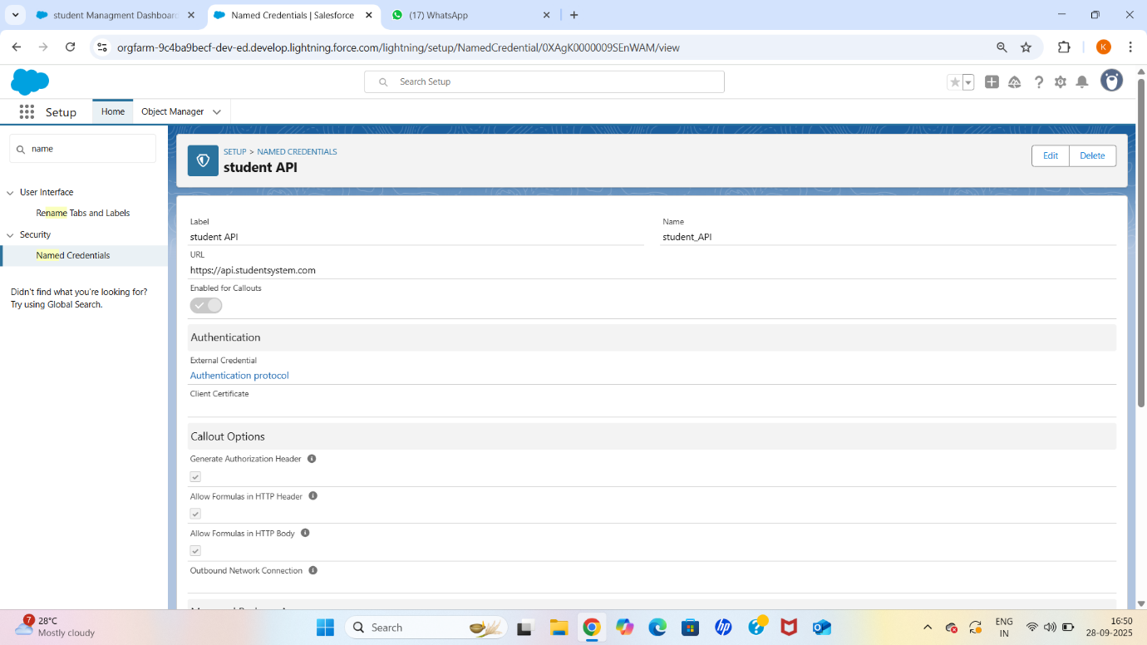

**2. External Services**

* **Registered External Schema:** Connected to the external Student REST API using the schema definition.
* Auto-generated Apex classes for:
  + Fetching student details.
  + Creating or updating student records externally.
* Purpose: Allow declarative integration (Flow & Apex) without manually writing callout code.

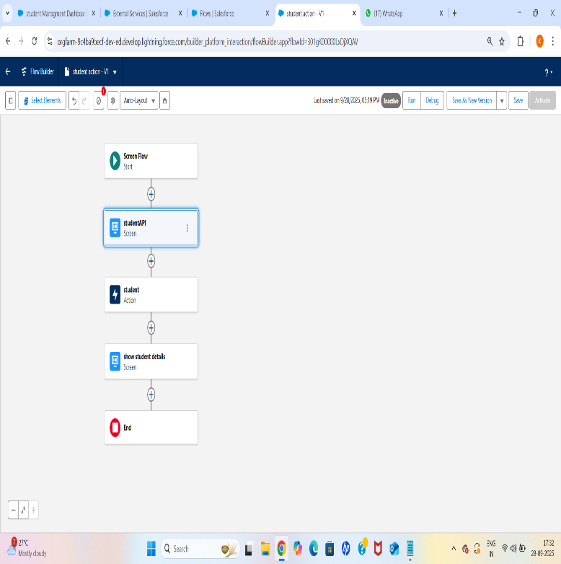

**3. Web Services (REST/SOAP)**

* **Developed REST Apex Class:** StudentRESTService
* Exposed endpoints:
  + /students → Create or update student records.
  + /students/{id} → Fetch student details by Student_ID__c.
* Added proper authentication and exception handling.
* Purpose: Allow external systems to push and pull student data securely.

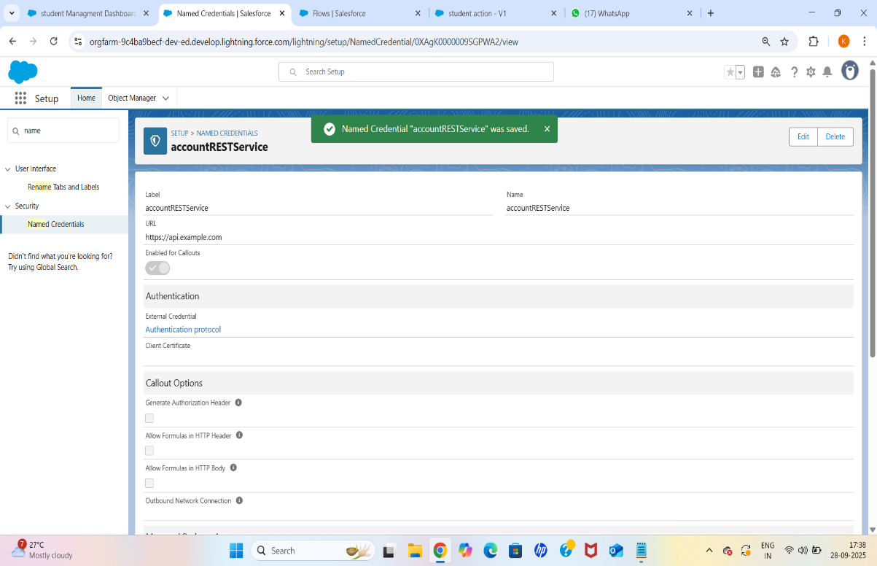

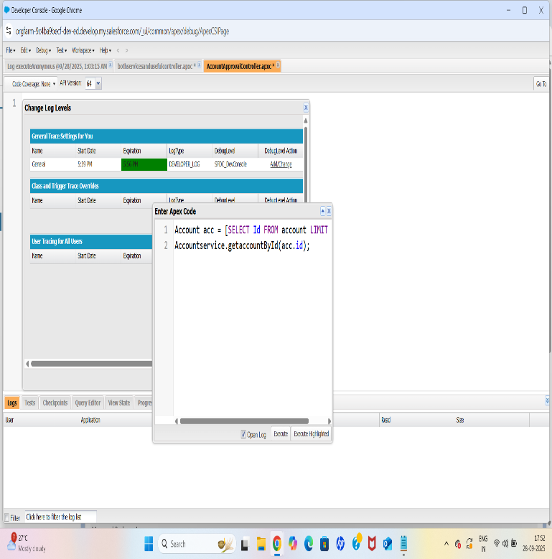

**4. Callouts**

* **Created Apex Callout Class:** CalloutExample
* Added test class with HttpCalloutMock to enable test coverage.
* Verified callout works with Remote Site Settings and Named Credentials.
* Purpose: Send student updates from Salesforce to external systems when a record is created or updated.

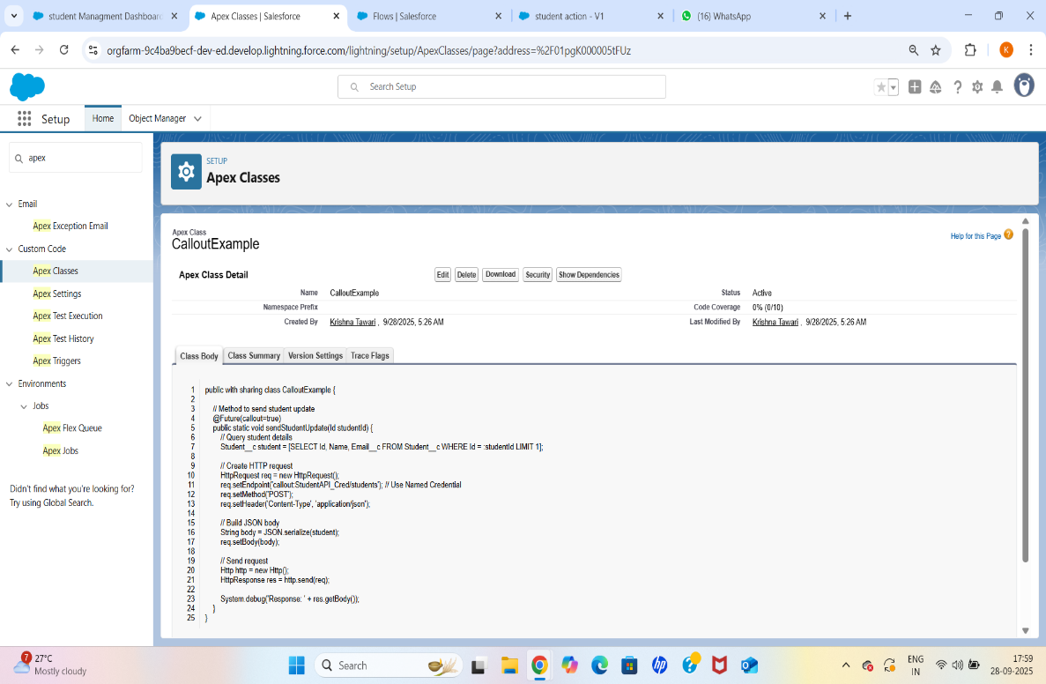

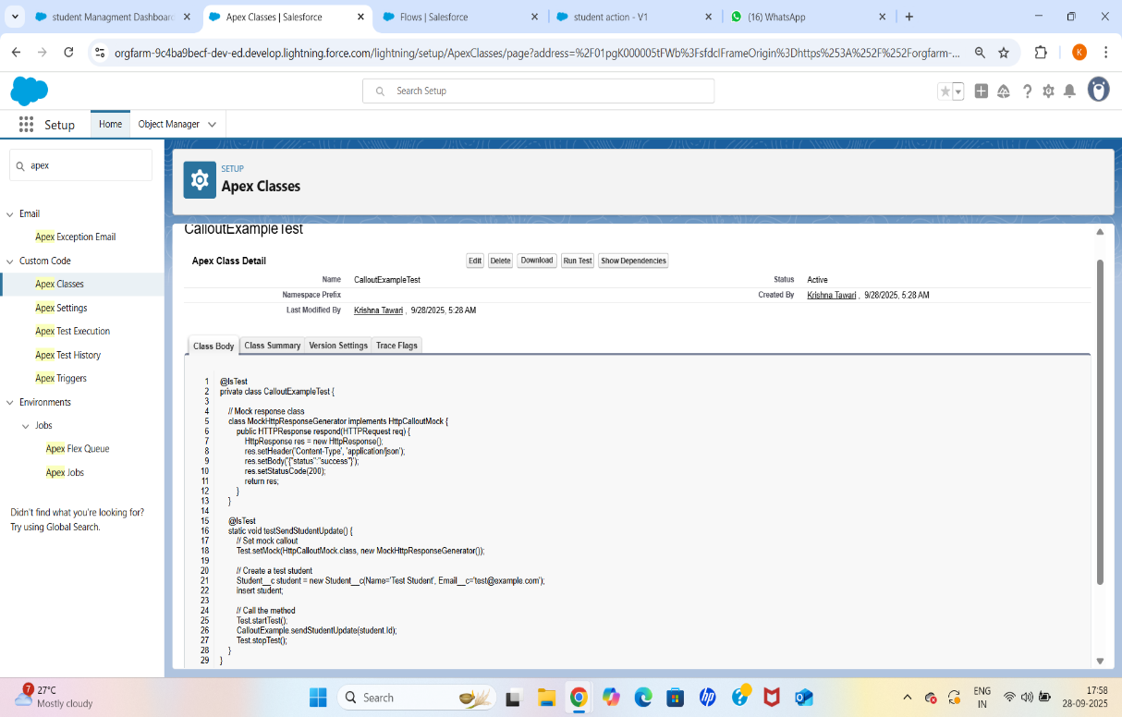

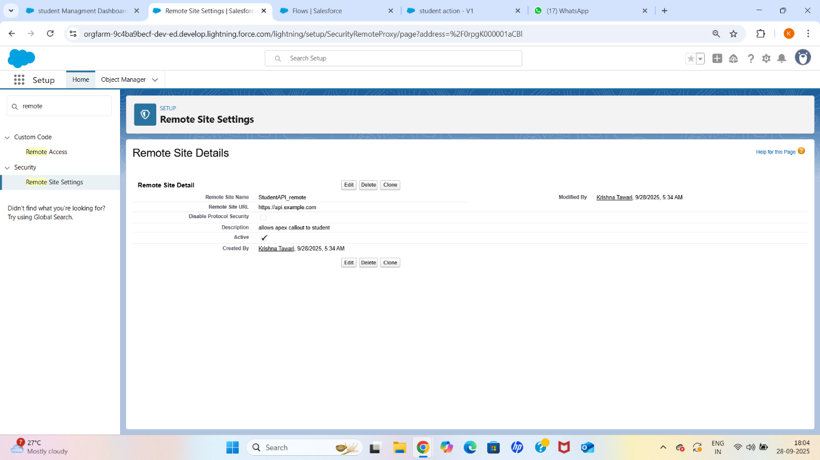

**5. Platform Events**

* **Created Platform Event:** Student_Event__e
* Custom Fields:
  + Student_ID__c (Text)
  + First_Name__c (Text)
  + Last_Name__c (Text)
  + Course_Program__c (Text)
  + Grade_Marks__c (Text)
  + Semester__c (Number)
  + Status__c (Checkbox)
  + Timestamp__c (Date/Time)
* Purpose: Publish student data changes to subscribers (internal or external) in real time.

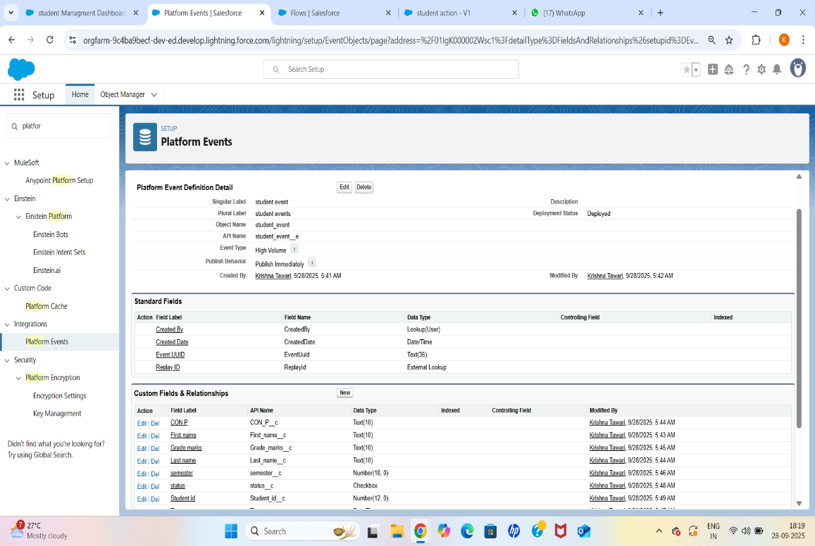

**6. Change Data Capture (CDC)**

* **Enabled CDC for Student__c object**
* **Created Apex Trigger:** StudentChangeTrigger
  + Logs change type, changed fields, and commit timestamp.
  + Takes action when Grade_Marks__c is updated.
* Purpose: Monitor and respond to changes in real time without writing complex logic.

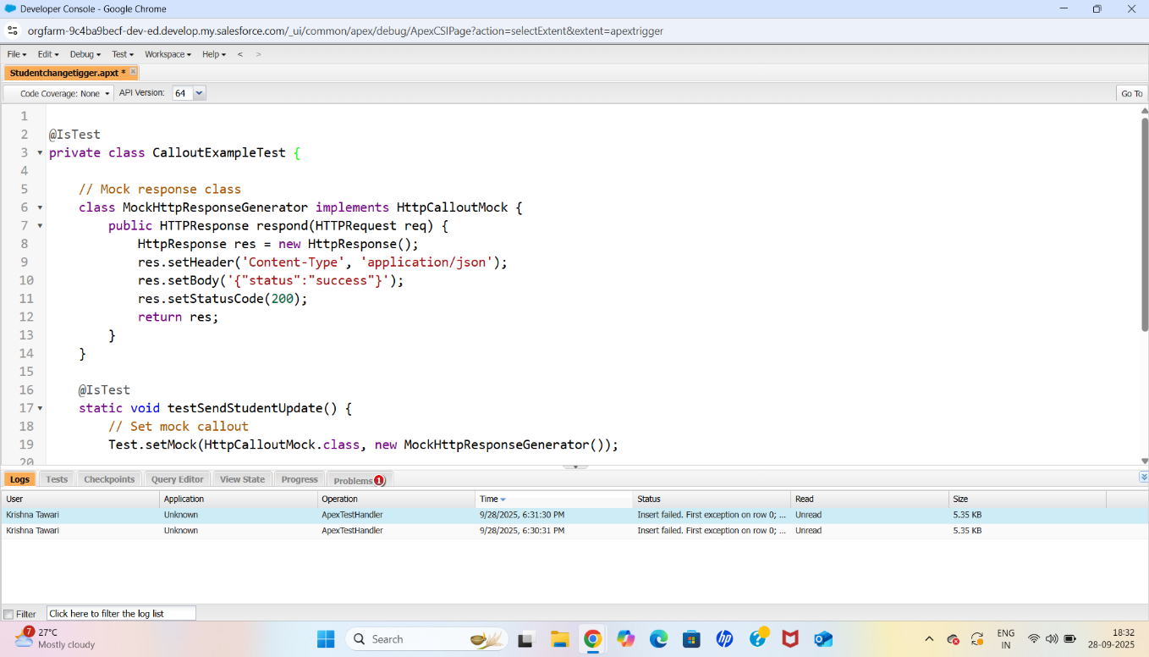

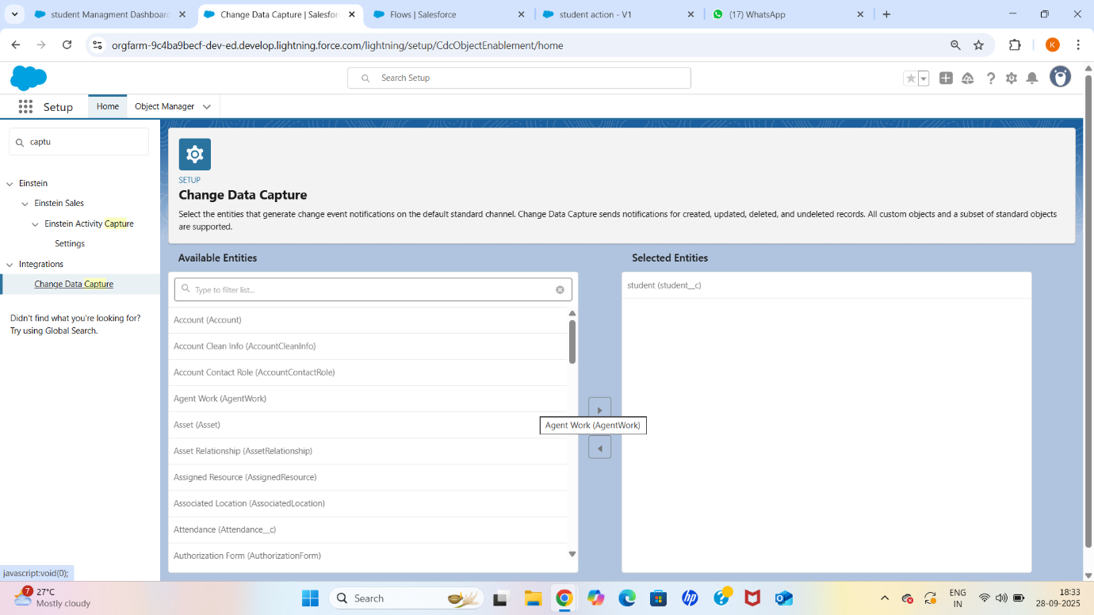

**7. Salesforce Connect**

* Configured **External Object** (Student_External__x) to display external student data within Salesforce.
* Verified CRUD operations (read-only or writable depending on requirement).
* Purpose: Provide a unified view of external student records directly in Salesforce UI.

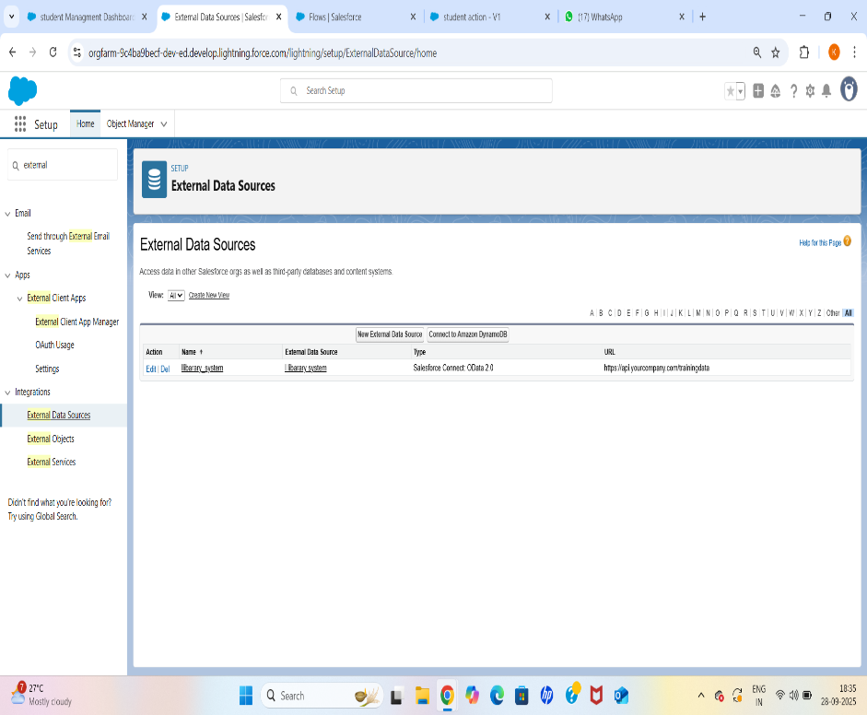

**8. API Limits**

* Enabled **API Usage Notifications** to alert when API usage reaches 75% and 90%.
* Monitored API calls through **System Overview** and **Reports**.
* Purpose: Prevent API over-consumption and avoid service interruptions.

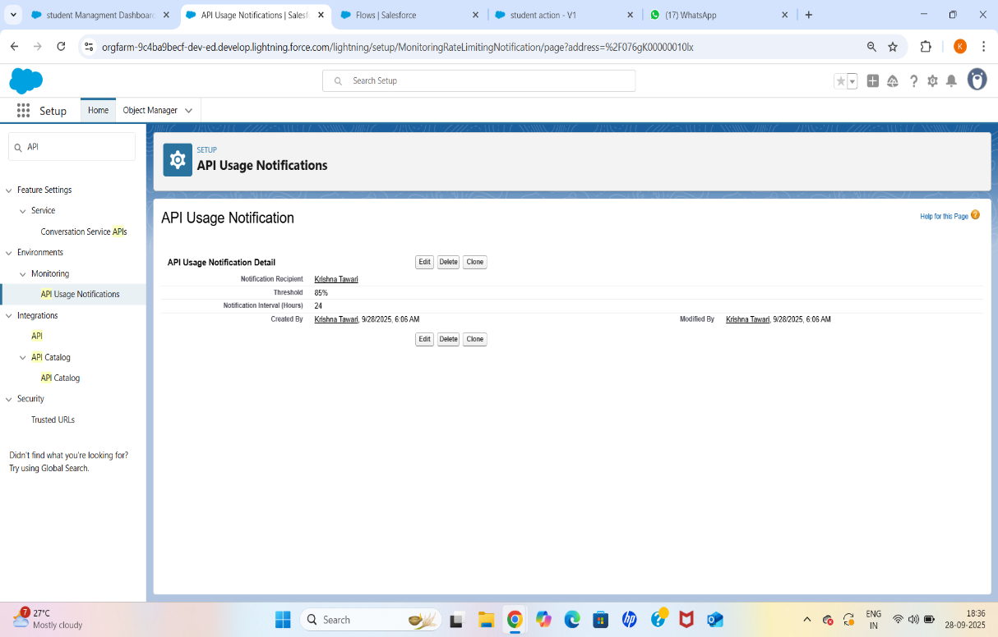

**9. OAuth & Authentication**

* **Created Connected App:** StudentManagementIntegration
* Configured OAuth scopes:
  + Full Access (full)
  + Perform requests on your behalf at any time (refresh_token, offline_access)
* Assigned profiles/permission sets.
* Tested authentication using Postman and verified in **Connected Apps OAuth Usage**.
* Purpose: Securely allow external applications to authenticate and integrate.

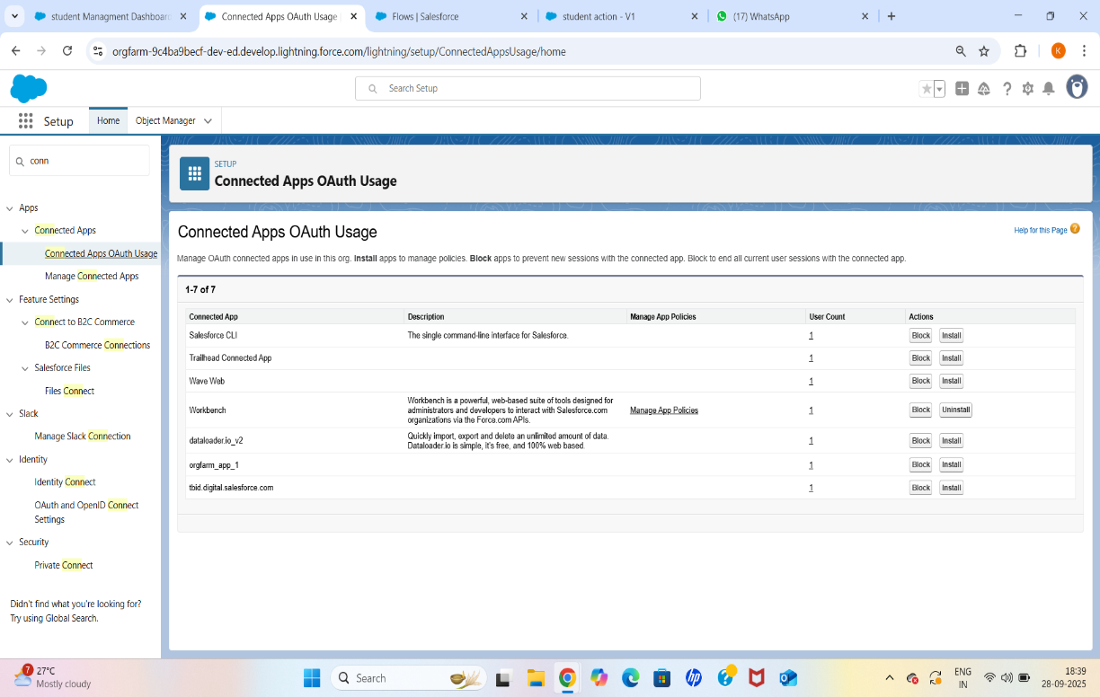

**10. Remote Site Settings**

* **Created Remote Site:** Student_API_Remote_Site
* Added base URL of external API to allow callouts.
* Purpose: Ensure Salesforce can make HTTPS callouts to the external Student API.

